KE Fisher 031319

2017 & 2018 Greenhouse Experiments

Data Analysis for Manuscript

Observation Stats “030519_PostStatsConsult_Observation&TTest.R”

* Leaves in First 24 Hours
* Biomass Consumed Over Full Development
* Leaves with Feeding Injury over full development
* Biomass from Natal
* Biomass from Subsequent Plants
  + T-test: Do they feed more from natal or subsequent - biomass?
* Leaves from Natal
* Leaves from Subsequent Plants
  + T-test: Do they feed more from natal or subsequent - leaves?
* Number of Plants Visited
* 2018 – Plants with Feeding Injury through development
* Larval Detection Error

Wilcoxon Sign Rank “030519_PostStatsConsult_Observation&TTest.R”

* Day Movement vs Night Movement

Proportion Analysis – R Markdown “030619_GH17&18_PostStatsConsult_proportions.Rmd”

* Observed On Plant Material ***way under dispersed – was significant before; different test?
* Portion of plant (top, middle bottom)
* Portion of leaf (top, underside, new growth)

GLM/Chi Square Analysis – R markdown “030519_GH17&18_PostStatsConsult_glm&chisquare_RMD.Rmd”

***Things that are analyzed as only 2017 could instead be analyzed as only cages with 4 plants in both 2017 and 2018

* Days Until Natal Abandonment – 2017 &2018
* Instar at Natal Abandonment – 2017 & 2018
* Plant Rank at Natal Abandonment – 2018? ***over dispersed -> just summarize
* Days to Pupation – only 2017
* Pupal Weight – only 2017
* Pupal Duration – only 2017
* Neonate to Adult Development – only 2017
* Biomass Consumed by Instar at Abandonment – only 2018
* Leaves Consumed by Instar at Abandonment – only 2018
* On Stem Movement by Instar – 2018
* Among Plant Movements – only 2017
* Total Plant Abandonments – only 2017
* Abandonment by Instar – only 2017
* Among Plant Movements by Instar – only 2017

Survival 0/1 Analysis

* Survival to Pupation ***over dispersed

Observation Stats

**From All Cages in 2018**

* Leaves in First 24 Hours

> foleaves<- summarySE(firstobs, measurevar="Leaves", groupvars=c("NumPlants"))

> foleaves

NumPlants N Leaves sd se ci

1 2 40 1.425000 0.7120753 0.11258900 0.2277327

2 3 38 1.500000 0.5575041 0.09043911 0.1832470

3 4 39 1.384615 0.5436419 0.08705238 0.1762283

**From Cages with Four Plants in 2018**

* Biomass Consumed Over Full Development

> biomass2 = Full$TotalBiomass

> length(biomass2)

[1] 9

> mean(biomass2)

[1] 1209.612

> sd(biomass2)

[1] 412.2984

> max(biomass2)

[1] 1724.052

> min(biomass2)

[1] 654.9688

* Leaves with Feeding Injury over full development

> leaves2=Full$TotalLeaves

> length(leaves2)

[1] 9

> mean(leaves2)

[1] 17.11111

> sd(leaves2)

[1] 5.085382

> max(leaves2)

[1] 23

> min(leaves2)

[1] 8

* Biomass from Natal

> bionatal=Full$NatalBiomass

> length(bionatal)

[1] 9

> mean(bionatal)

[1] 119.0387

> sd(bionatal)

[1] 164.8016

> max(bionatal)

[1] 531.876

> min(bionatal)

[1] 3.424619

* Biomass from Subsequent Plants

> biosub=Full$SubsequentBiomass

> length(biosub)

[1] 9

> mean(biosub)

[1] 1090.573

> sd(biosub)

[1] 401.1351

> max(biosub)

[1] 1688.728

> min(biosub)

[1] 601.6863

T-Test

* Do they feed more from natal or subsequent - biomass?

> t.test(Biomass ~ Plant, fullt)

Welch Two Sample t-test

data: Biomass by Plant

t = -6.7208, df = 10.626, p-value = 3.891e-05

alternative hypothesis: true difference in means is not equal to 0

95 percent confidence interval:

-1291.0734 -651.9958

sample estimates:

mean in group Natal mean in group Subsequent

119.0387 1090.5733

* Leaves from Natal

> leavesnat=Full$NatalLeaves

> length(leavesnat)

[1] 9

> mean(leavesnat)

[1] 5.777778

> sd(leavesnat)

[1] 2.948634

> max(leavesnat)

[1] 10

> min(leavesnat)

[1] 1

* Leaves from Subsequent Plants

> leavessub=Full$SubseLeaves

> length(leavessub)

[1] 9

> mean(leavessub)

[1] 11.33333

> sd(leavessub)

[1] 3.872983

> max(leavessub)

[1] 18

> min(leavessub)

[1] 6

T-Test

* Do they feed more from natal or subsequent - leaves?

> t.test(Leaves ~ Plant, fullt)

Welch Two Sample t-test

data: Leaves by Plant

t = -3.4239, df = 14.942, p-value = 0.003786

alternative hypothesis: true difference in means is not equal to 0

95 percent confidence interval:

-9.015143 -2.095968

sample estimates:

mean in group Natal mean in group Subsequent

5.777778 11.333333

* 2018 – Plants with Feeding Injury through development (only 4 plant cages)

> plants2=Full$PlantsWithFeeding

> length(plants2)

[1] 9

> mean(plants2)

[1] 3.222222

> sd(plants2)

[1] 0.4409586

> max(plants2)

[1] 4

> min(plants2)

[1] 3

**From All Cages in 2017 and those with 4 plants in 2018**

* Number of Plants Visited

Separated by year

> numplantsv<- summarySE(GH1718, measurevar="NumPlantsVisited", groupvars=c("NumPlants","Year"))

> numplantsv

NumPlants Year N NumPlantsVisited sd se ci

1 2 2017 29 1.965517 0.1856953 0.03448276 0.07063473

2 3 2017 21 2.333333 0.7302967 0.15936381 0.33242709

3 4 2017 27 2.925926 0.7808243 0.15026971 0.30888381

4 4 2018 25 3.000000 0.8164966 0.16329932 0.33703322

4 plants combined over 17 and 18

> numplantsv<- summarySE(GH1718, measurevar="NumPlantsVisited", groupvars=c("NumPlants"))

> numplantsv

NumPlants N NumPlantsVisited sd se ci

1 2 29 1.965517 0.1856953 0.03448276 0.07063473

2 3 21 2.333333 0.7302967 0.15936381 0.33242709

3 4 52 2.961538 0.7911654 0.10971490 0.22026185

Only 2017

> numplantsv<- summarySE(GH1718.complete, measurevar="NumPlantsVisited", groupvars=c("NumPlants"))

> numplantsv

NumPlants N NumPlantsVisited sd se ci

1 2 29 1.965517 0.1856953 0.03448276 0.07063473

2 3 21 2.333333 0.7302967 0.15936381 0.33242709

3 4 27 2.925926 0.7808243 0.15026971 0.30888381

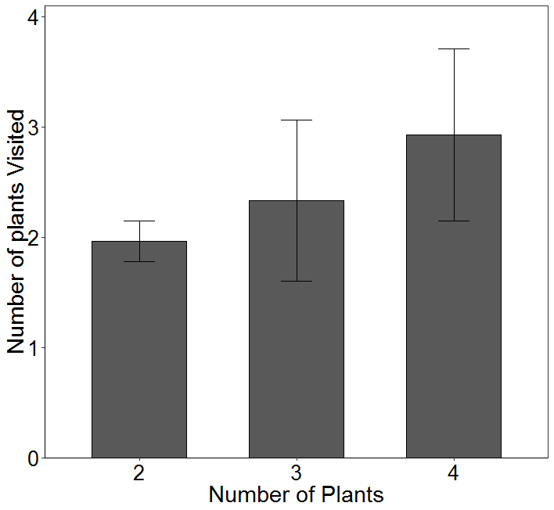

Plot of only 2017 values

***NO TEST OF SIGNIFICANCE!***

* Day Movement vs Night Movement

> ampm2<-read.csv("030719_AMPM_Movement_GH17.csv", header=TRUE)

> ampmplot<- summarySE(ampm2, measurevar="Movements", groupvars=c("Time", "Plants"))

> ampmplot

Time Plants N Movements sd se ci

1 AtNight 2 29 1.310345 1.1371471 0.2111629 0.4325476

2 AtNight 3 21 1.285714 0.9561829 0.2086562 0.4352492

3 AtNight 4 27 1.111111 0.9740215 0.1874505 0.3853101

4 DuringDay 2 29 2.379310 1.1775821 0.2186715 0.4479283

5 DuringDay 3 21 2.380952 1.0235326 0.2233531 0.4659065

6 DuringDay 4 27 2.370370 1.4714762 0.2831857 0.5820966

> ampmplot2<- summarySE(ampm2, measurevar="Movements", groupvars=c("Time"))

> ampmplot2

Time N Movements sd se ci

1 AtNight 77 1.233766 1.024645 0.1167691 0.2325659

2 DuringDay 77 2.376623 1.235856 0.1408389 0.2805050

Wilcoxon Sign Rank

> ampm<- read.csv("012219_AMPM_Movement_GH17.csv", header=TRUE)

> wilcox.test(ampm$AM, ampm$PM, paired = TRUE, alternative = "two.sided")

Wilcoxon signed rank test with continuity correction

data: ampm$AM and ampm$PM

V = 203, p-value = 3.608e-08

alternative hypothesis: true location shift is not equal to 0

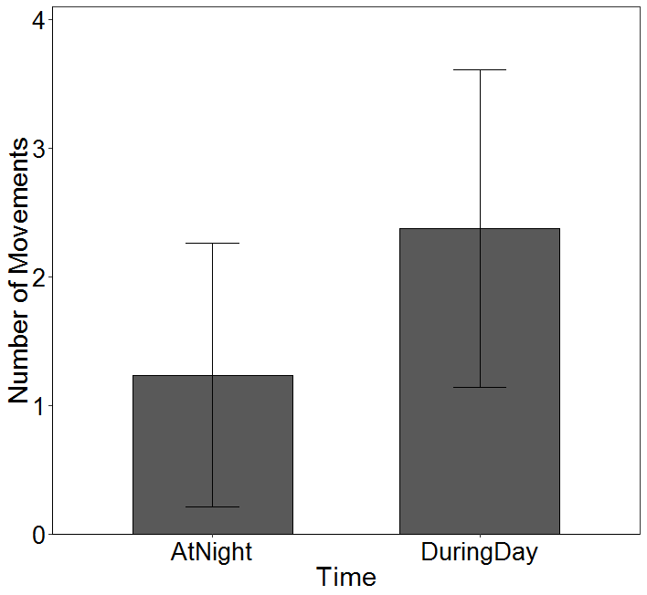

**From All Cages in 2017 and 2018**

* Larval Detection Error – in Excel file “012119_GH17&18_Survival&Missing.xlsx”

Despite using cages that confined movement of the larvae, 43 larvae were reported missing 93 times across the total 3,890 sampling periods in all 2017 and 2018 experiments. Twenty-six larvae were not detected 38 times, but were observed alive in the first or second subsequent sampling periods; i.e., in 0.977% of the 3,890 observations larvae were not detected in a sampling period; however, they were not dead. Fifty percent of the instances when larvae were missing but subsequently observed (missing on observation period one and found on observation period two), they were found on the same plant and 50% of the time larvae were found on another plant. There did not appear to be a relationship between instar stage and detection error: of the 38 times larvae were reported missing but subsequently found alive (26 larvae, some missing more than once), 1st, 2nd, 3rd, 4th and 5th, instars were missing 8, 11, 6, 7, and 6 times, respectively. Nineteen of the individuals (7.5% of the total) were never recovered and assumed to have died. Of these, most were first recorded as missing in either the first or second instar. Missing 1st, 2nd, 3rd, 4th and 5th instars were not recovered 10, 8, 1, 0, and 0 times, respectively.

Can give more specific values after the rest of the analysis is complete.

Proportion Analysis

**From All Cages in 2017**

* Observed On Plant Material

> relplant <- glm(RelPlant ~ NumPlants + Trial + Trial:NumPlants + YearBlock, data=GH1718.complete, family = binomial, na.action = "na.omit")

> #Test for overdispersion

> summary(relplant)$deviance/summary(relplant)$df.residual

[1] 0.08734734

WAY UNDER DISPERSED!!

> #Test for significance

> dtm.emm <- emmeans(relplant, c("NumPlants", "Trial", "YearBlock"), type='response')

> joint_tests(dtm.emm)

model term df1 df2 F.ratio p.value

NumPlants 2 Inf 0.414 0.6613

Trial 3 Inf 0.097 0.9617

YearBlock 2 Inf 0.009 0.9915

NumPlants:Trial 6 Inf 0.088 0.9975

> SErp<- summarySE(GH1718.complete, measurevar="RelPlant", groupvars=c("NumPlants","Year"))

> SErp

NumPlants Year N RelPlant sd se ci

1 2 2017 29 0.8247306 0.08162650 0.01515766 0.03104906

2 3 2017 21 0.8603612 0.09994822 0.02181049 0.04549588

3 4 2017 27 0.9095579 0.08219909 0.01581922 0.03251688

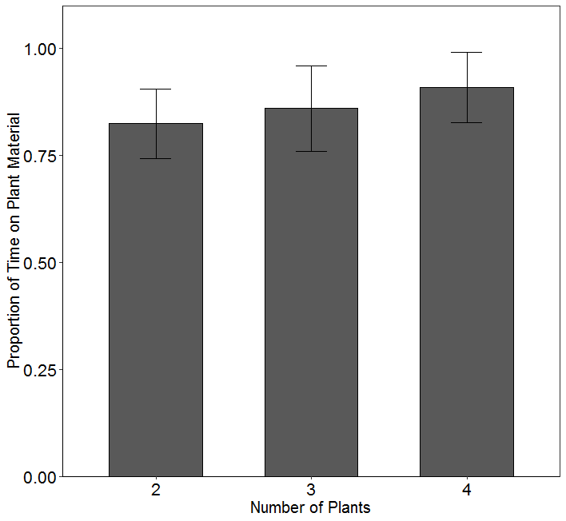

Not significant with this model, but was significant previously. Data is VERY under dispersed. Is there another test?

**From all cages in 2018 full observation**

* Portion of plant (top, middle bottom)

> location <- glm(LocRelativeTime ~ Location + NumPlants + Trial + Trial:NumPlants + YearBlock, data=loc, family = binomial, na.action = "na.omit")

> #Test for significance

> dtm.emm <- emmeans(location, c("Location", "NumPlants", "Trial", "YearBlock"), type='response')

> joint_tests(dtm.emm)

model term df1 df2 F.ratio p.value

Location 2 Inf 32.993 <.0001

NumPlants 2 Inf 0.000 1.0000

Trial 2 Inf 0.000 1.0000

YearBlock 8 Inf 0.000 1.0000

NumPlants:Trial 4 Inf 0.000 1.0000

> pairs(dtm.emm2)

contrast odds.ratio SE df z.ratio p.value

Bottom / Middle 0.199 0.1066 Inf -3.013 0.0073

Bottom / Top 0.024 0.0127 Inf -7.060 <.0001

Middle / Top 0.121 0.0425 Inf -6.005 <.0001

Results are averaged over the levels of: NumPlants, Trial, YearBlock

P value adjustment: tukey method for comparing a family of 3 estimates

Tests are performed on the log odds ratio scale

> SEloc<- summarySE(loc, measurevar="LocRelativeTime", groupvars=c("Location"))

> SEloc$Sig<- NA

> SEloc$Sig<- c("a","b","c")

> SEloc

Location N LocRelativeTime sd se ci Sig

1 Bottom 85 0.05629427 0.08006052 0.008683783 0.01726865 a

2 Middle 85 0.23089802 0.16272760 0.017650287 0.03509953 b

3 Top 85 0.71280771 0.18073712 0.019603693 0.03898409 c

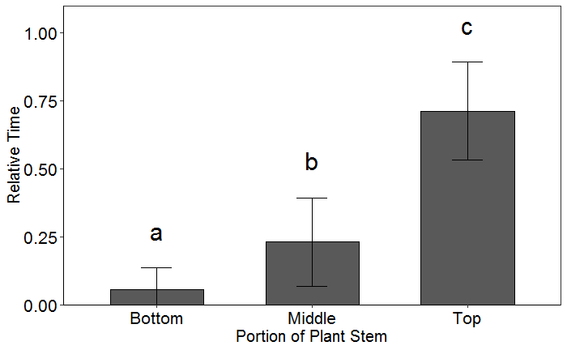

* Portion of leaf (top, underside, new growth)

> surface <- glm(SurRelativeTime ~ LeafSurf + NumPlants + Trial + Trial:NumPlants + YearBlock, data=sur, family = binomial, na.action = "na.omit")

> dtm.emm <- emmeans(surface, c("LeafSurf", "NumPlants", "Trial", "YearBlock"), type='response')

> joint_tests(dtm.emm)

model term df1 df2 F.ratio p.value

LeafSurf 3 Inf 19.806 <.0001

NumPlants 2 Inf 0.000 1.0000

Trial 2 Inf 0.000 1.0000

YearBlock 8 Inf 0.000 1.0000

NumPlants:Trial 4 Inf 0.000 1.0000

|  |
| --- |
| > pairs(dtm.emm2)  contrast odds.ratio SE df z.ratio p.value  New Growth / Stem 8.8501 6.2197 Inf 3.103 0.0104  New Growth / Top 1.3361 0.5304 Inf 0.730 0.8851  New Growth / Underside 0.1738 0.0604 Inf -5.037 <.0001  Stem / Top 0.1510 0.1076 Inf -2.652 0.0400  Stem / Underside 0.0196 0.0135 Inf -5.725 <.0001  Top / Underside 0.1301 0.0478 Inf -5.550 <.0001  Results are averaged over the levels of: NumPlants, Trial, YearBlock  P value adjustment: tukey method for comparing a family of 4 estimates  Tests are performed on the log odds ratio scale  > SEsur<- summarySE(sur, measurevar="SurRelativeTime", groupvars=c("LeafSurf"))  > SEsur$Sig<- NA  > SEsur$Sig<- c("a","c","a", "b")  > SEsur  LeafSurf N SurRelativeTime sd se ci Sig  1 New Growth 85 0.20719076 0.17360629 0.018830246 0.03744601 a  2 Stem 85 0.02868232 0.04657785 0.005052077 0.01004661 c  3 Top 85 0.16359390 0.09867741 0.010703068 0.02128422 a  4 Underside 85 0.60053301 0.19663368 0.021327917 0.04241290 b |
|  |
| |  | | --- | |  | |

GLM/Chi Square Analysis – R markdown

***Things that are analyzed as only 2017 could instead be analyzed as only cages with 4 plants in both 2017 and 2018

* Days Until Natal Abandonment – 2017 & 2018

> daystomove <- glm(DaysToMove ~ YearBlock + Trial + NumPlants + Trial:NumPlants, data=Natal, family = poisson(link = "log"))

> # Test for significance of NumPlants

> dtm.emm <- emmeans(daystomove, c("NumPlants", "Trial", "YearBlock"), type='response')

> joint_tests(dtm.emm)

model term df1 df2 F.ratio p.value note

NumPlants 2 Inf 0.201 0.8179

Trial 5 Inf 1.594 0.1578 e

YearBlock 10 Inf 0.351 0.9666 e

NumPlants:Trial 12 Inf 0.582 0.8585

e: df1 reduced due to non-estimability

> SEDays<- summarySE(Natal, measurevar="DaysToMove", groupvars=c("NumPlants"))

> SEDays

NumPlants N DaysToMove sd se ci

1 2 55 6.727273 2.040829 0.2751853 0.5517134

2 3 55 6.327273 2.055296 0.2771361 0.5556244

3 4 52 6.615385 2.529464 0.3507736 0.7042074

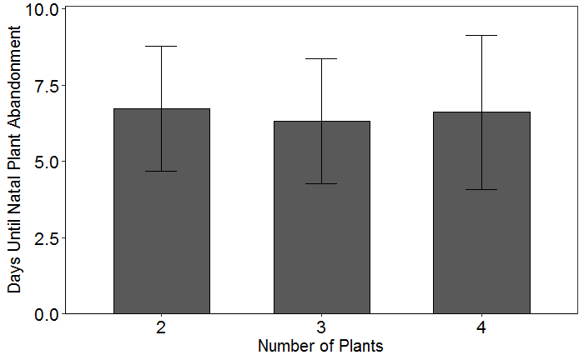

> Days=Natal$DaysToMove

> mean(Days)

[1] 6.555556

> sd(Days)

[1] 2.206709

> max(Days)

[1] 12

> min(Days)

[1] 1

* Instar at Natal Abandonment – 2017 & 2018

> instar <- glm(InstarToMove ~ YearBlock + Trial + NumPlants + Trial:NumPlants, data=Natal, family = poisson(link = "log"))

> # Test for significance of NumPlants

> dtm.emm <- emmeans(instar, c("NumPlants", "Trial", "YearBlock"), type='response')

> joint_tests(dtm.emm)

model term df1 df2 F.ratio p.value note

NumPlants 2 Inf 0.008 0.9921

Trial 5 Inf 0.591 0.7067 e

YearBlock 10 Inf 0.093 0.9999 e

NumPlants:Trial 12 Inf 0.194 0.9987

e: df1 reduced due to non-estimability

> SEInstar<- summarySE(Natal, measurevar="InstarToMove", groupvars=c("NumPlants"))

> SEInstar

NumPlants N InstarToMove sd se ci

1 2 55 4.036364 0.8598802 0.1159462 0.2324582

2 3 55 3.945455 0.8480518 0.1143513 0.2292605

3 4 52 3.942308 1.0368403 0.1437839 0.2886582

> Instar=Natal$InstarToMove

> mean(Instar)

[1] 3.975309

> sd(Instar)

[1] 0.9119675

> max(Instar)

[1] 5

> min(Instar)

[1] 1

> result<-getmode(Instar)

> print(result)

[1] 4

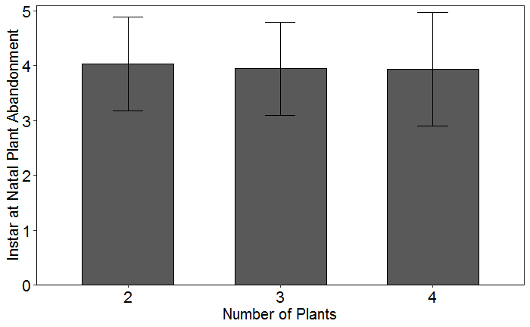

* Plant Rank at Natal Abandonment – 2018?

> rank <- glm(PlantRank ~ YearBlock + Trial + NumPlants + Trial:NumPlants, data=Rank, family = poisson(link = "log"))

> #Test for overdispersion

> summary(rank)$deviance/summary(rank)$df.residual

[1] 1.271998

* Days to Pupation – only 2017

> pday <- glm(PDay ~ YearBlock + Trial + NumPlants + Trial:NumPlants, data=GH17, family = poisson(link = "log"))

> # Test for significance of NumPlants

> dtm.emm <- emmeans(pday, c("NumPlants", "Trial", "YearBlock"), type='response')

> joint_tests(dtm.emm)

model term df1 df2 F.ratio p.value

NumPlants 2 Inf 0.096 0.9080

Trial 3 Inf 2.158 0.0907

YearBlock 2 Inf 0.083 0.9205

NumPlants:Trial 6 Inf 0.134 0.9920

> SEPDay<- summarySE(GH17, measurevar="PDay", groupvars=c("NumPlants"))

> SEPDay

NumPlants N PDay sd se ci

1 2 29 11.86207 1.884602 0.3499618 0.7168642

2 3 21 11.71429 1.677583 0.3660787 0.7636268

3 4 27 11.33333 1.300887 0.2503559 0.5146139

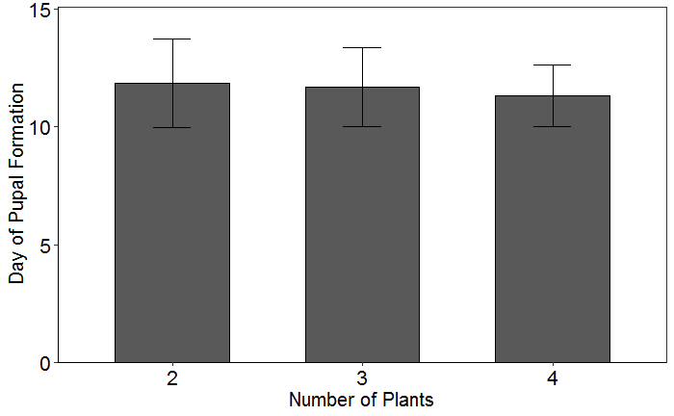

> mean(PDay)

[1] 11.63636

> sd(PDay)

[1] 1.637626

> max(PDay)

[1] 17

> min(PDay)

[1] 9

> result<-getmode(PDay)

> print(result)

[1] 11

* Pupal Weight – only 2017

> pweight <- glm(PWeight ~ YearBlock + Trial + NumPlants + Trial:NumPlants, data=Weight, family = poisson(link = "log"))

> # Test for significance of NumPlants

> dtm.emm <- emmeans(pweight, c("NumPlants", "Trial", "YearBlock"), type='response')

> joint_tests(dtm.emm)

model term df1 df2 F.ratio p.value

NumPlants 2 Inf 0.031 0.9693

Trial 3 Inf 0.123 0.9466

YearBlock 2 Inf 0.044 0.9573

NumPlants:Trial 6 Inf 0.033 0.9998

> SEPWeight<- summarySE(Weight, measurevar="PWeight", groupvars=c("NumPlants"))

> SEPWeight

NumPlants N PWeight sd se ci

1 2 28 1.258571 0.2471874 0.04671402 0.09584925

2 3 21 1.280476 0.1354428 0.02955605 0.06165284

3 4 27 1.326667 0.1713072 0.03296808 0.06776687

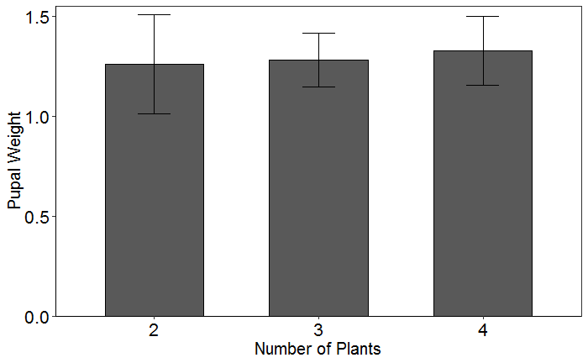

> PWeight=Weight$PWeight

> mean(PWeight)

[1] 1.288816

> sd(PWeight)

[1] 0.1947783

> max(PWeight)

[1] 1.61

> min(PWeight)

[1] 0.74

* Pupal Duration – only 2017

> pdur <- glm(PDuration ~ YearBlock + Trial + NumPlants + Trial:NumPlants, data=PDur, family = poisson(link = "log"))

> # Test for significance of NumPlants

> dtm.emm <- emmeans(pdur, c("NumPlants", "Trial", "YearBlock"), type='response')

> joint_tests(dtm.emm)

model term df1 df2 F.ratio p.value

NumPlants 2 Inf 0.053 0.9485

Trial 3 Inf 1.074 0.3585

YearBlock 2 Inf 0.004 0.9961

NumPlants:Trial 6 Inf 0.150 0.9891

> SEPDur<- summarySE(PDur, measurevar="PDuration", groupvars=c("NumPlants"))

> SEPDur

NumPlants N PDuration sd se ci

1 2 27 9.851852 1.406132 0.2706103 0.5562474

2 3 21 9.619048 1.283596 0.2801036 0.5842860

3 4 27 9.481481 0.935224 0.1799839 0.3699623

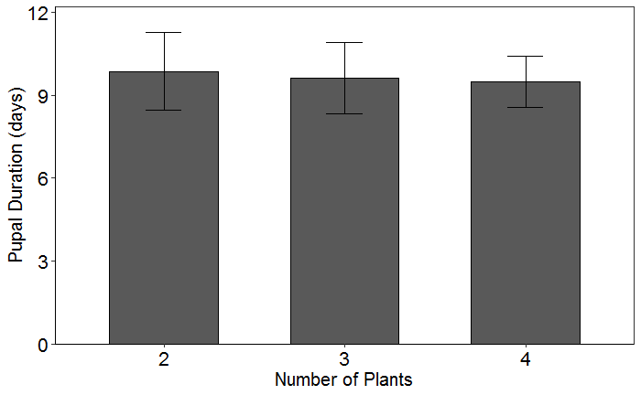

> PDur2=PDur$PDuration

> mean(PDur2)

[1] 9.653333

> sd(PDur2)

[1] 1.213587

> max(PDur2)

[1] 12

> min(PDur2)

[1] 5

* Neonate to Adult Development – only 2017

> neo <- glm(NeoToAdult ~ YearBlock + Trial + NumPlants + Trial:NumPlants, data=PDur, family = poisson(link = "log"))

> # Test for significance of NumPlants

> dtm.emm <- emmeans(neo, c("NumPlants", "Trial", "YearBlock"), type='response')

> joint_tests(dtm.emm)

model term df1 df2 F.ratio p.value

NumPlants 2 Inf 0.113 0.8929

Trial 3 Inf 2.989 0.0297

YearBlock 2 Inf 0.061 0.9409

NumPlants:Trial 6 Inf 0.169 0.9850

> SEPDur<- summarySE(PDur, measurevar="NeoToAdult", groupvars=c("NumPlants"))

> SEPDur

NumPlants N NeoToAdult sd se ci

1 2 27 21.74074 2.836474 0.5458797 1.1220717

2 3 21 21.28571 2.452404 0.5351584 1.1163209

3 4 27 20.88889 1.967688 0.3786817 0.7783913

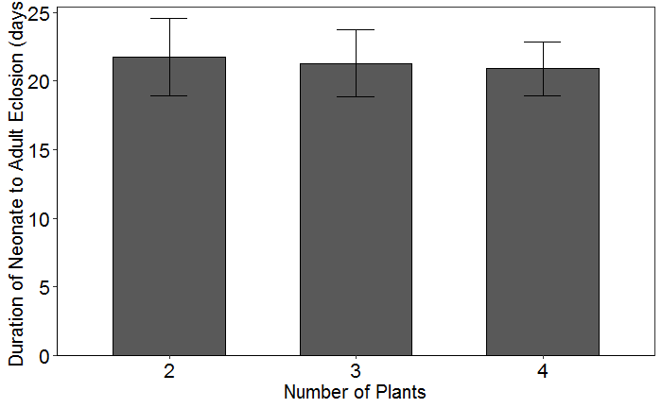

> Neo=PDur$NeoToAdult

> mean(Neo)

[1] 21.30667

> sd(Neo)

[1] 2.438283

> max(Neo)

[1] 27

> min(Neo)

[1] 16

> result<-getmode(Neo)

> print(result)

[1] 22

* Biomass Consumed by Instar at Abandonment – only 2018

> biomass <- glm(Biomass ~ YearBlock + Trial + NumPlants + MoveInstar + Trial:NumPlants + NumPlants:MoveInstar, data=Bio, family = Gamma(link = "inverse"))

> dtm.emm <- emmeans(biomass, c("NumPlants", "Trial", "YearBlock", "MoveInstar"), type='response')

> joint_tests(dtm.emm)

model term df1 df2 F.ratio p.value

NumPlants 2 Inf 0.086 0.9179

Trial 2 Inf 3.556 0.0285

YearBlock 8 Inf 0.458 0.8862

MoveInstar 3 Inf 15.213 <.0001

NumPlants:Trial 4 Inf 1.854 0.1156

NumPlants:MoveInstar 6 Inf 1.036 0.3993

> dtm.emm2 <- emmeans(biomass, c("MoveInstar"), type='response')

> joint_tests(dtm.emm2)

model term df1 df2 F.ratio p.value

MoveInstar 3 Inf 15.213 <.0001

> pairs(dtm.emm2)

contrast estimate SE df z.ratio p.value

2 - 3 0.06143 0.02842 Inf 2.162 0.1340

2 - 4 0.10068 0.02596 Inf 3.878 0.0006

2 - 5 0.10851 0.02595 Inf 4.181 0.0002

3 - 4 0.03926 0.01176 Inf 3.338 0.0047

3 - 5 0.04708 0.01186 Inf 3.971 0.0004

4 - 5 0.00783 0.00187 Inf 4.179 0.0002

Results are averaged over the levels of: YearBlock, Trial, NumPlants

P value adjustment: tukey method for comparing a family of 4 estimates

> SEB<- summarySE(Bio, measurevar="Biomass", groupvars=c("MoveInstar"))

> SEB$Sig<- NA

> SEB$Sig<- c("a","a","b","c")

> SEB

MoveInstar N Biomass sd se ci Sig

1 2 8 9.032505 4.335631 1.532877 3.624678 a

2 3 14 21.663236 12.524209 3.347236 7.231263 a

3 4 39 99.605682 71.883027 11.510496 23.301782 b

4 5 13 731.512721 524.289359 145.411705 316.824888 c

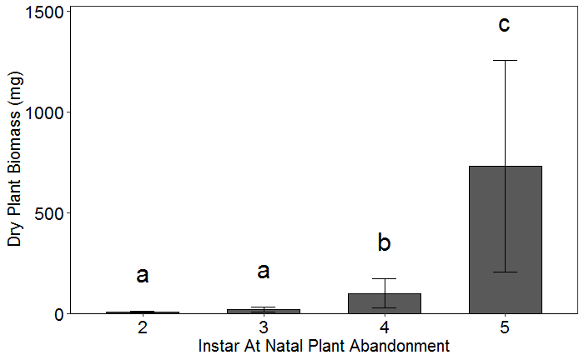

> Bio2=Bio$Biomass

> mean(Bio2)

[1] 186.0788

> sd(Bio2)

[1] 336.8955

> max(Bio2)

[1] 1689.137

> min(Bio2)

[1] 2.01672

* Leaves Consumed by Instar at Abandonment – only 2018

> leaf <- glm(Leaves ~ YearBlock + Trial + NumPlants + MoveInstar + Trial:NumPlants + NumPlants:MoveInstar, data=Leaf, family = Gamma(link = "inverse"))

> dtm.emm <- emmeans(leaf, c("NumPlants", "Trial", "YearBlock", "MoveInstar"), type='response')

> joint_tests(dtm.emm)

model term df1 df2 F.ratio p.value

NumPlants 2 Inf 1.766 0.1710

Trial 2 Inf 0.426 0.6531

YearBlock 8 Inf 1.621 0.1130

MoveInstar 3 Inf 12.899 <.0001

NumPlants:Trial 4 Inf 0.638 0.6356

NumPlants:MoveInstar 6 Inf 1.443 0.1937

> dtm.emm2 <- emmeans(leaf, c("MoveInstar"), type='response')

> joint_tests(dtm.emm2)

model term df1 df2 F.ratio p.value

MoveInstar 3 Inf 12.899 <.0001

> pairs(dtm.emm2)

contrast estimate SE df z.ratio p.value

2 - 3 -0.00907 0.0528 Inf -0.172 0.9982

2 - 4 0.08524 0.0440 Inf 1.937 0.2126

2 - 5 0.17017 0.0438 Inf 3.882 0.0006

3 - 4 0.09430 0.0346 Inf 2.727 0.0324

3 - 5 0.17924 0.0369 Inf 4.864 <.0001

4 - 5 0.08494 0.0195 Inf 4.362 0.0001

Results are averaged over the levels of: YearBlock, Trial, NumPlants

P value adjustment: tukey method for comparing a family of 4 estimates

> SEL<- summarySE(Leaf, measurevar="Leaves", groupvars=c("MoveInstar"))

> SEL$Sig<- NA

> SEL$Sig<- c("a","a","a","b")

> SEL

MoveInstar N Leaves sd se ci Sig

1 2 8 3.750000 1.488048 0.5261043 1.2440389 a

2 3 14 3.714286 1.857565 0.4964553 1.0725264 a

3 4 39 5.871795 2.142054 0.3430031 0.6943735 a

4 5 18 10.666667 5.017616 1.1826634 2.4952017 b

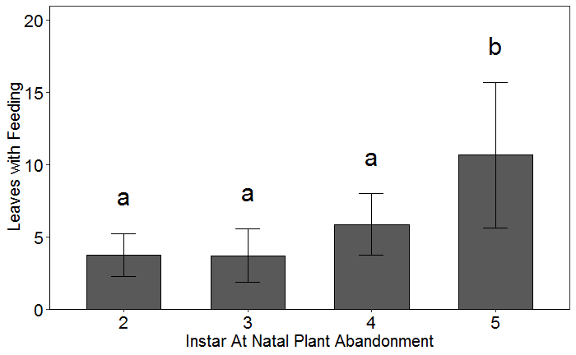

> leaf2=Leaf$Leaves

> mean(leaf2)

[1] 6.367089

> sd(leaf2)

[1] 3.85366

> max(leaf2)

[1] 22

> min(leaf2)

[1] 1

* On Stem Movement by Instar – 2018

> move <- glm(On.RametMvt ~ YearBlock + Trial + NumPlants + MoveInstar + Trial:NumPlants, data=Mvt, family = poisson(link = "log"))

> dtm.emm <- emmeans(move, c("NumPlants", "Trial", "YearBlock", "MoveInstar"), type='response')

> joint_tests(dtm.emm)

model term df1 df2 F.ratio p.value

NumPlants 2 Inf 0.988 0.3722

Trial 2 Inf 2.873 0.0565

YearBlock 8 Inf 1.532 0.1401

MoveInstar 3 Inf 16.016 <.0001

NumPlants:Trial 4 Inf 2.344 0.0523

> dtm.emm2 <- emmeans(move, c("MoveInstar"), type='response')

> joint_tests(dtm.emm2)

model term df1 df2 F.ratio p.value

MoveInstar 3 Inf 16.016 <.0001

> pairs(dtm.emm2)

contrast ratio SE df z.ratio p.value

2 / 3 0.451 0.2045 Inf -1.756 0.2947

2 / 4 0.358 0.1459 Inf -2.521 0.0567

2 / 5 0.154 0.0624 Inf -4.611 <.0001

3 / 4 0.794 0.2082 Inf -0.879 0.8156

3 / 5 0.341 0.0855 Inf -4.292 0.0001

4 / 5 0.430 0.0708 Inf -5.124 <.0001

Results are averaged over the levels of: YearBlock, Trial, NumPlants

P value adjustment: tukey method for comparing a family of 4 estimates

Tests are performed on the log scale

> SEB<- summarySE(Mvt, measurevar="On.RametMvt", groupvars=c("MoveInstar"))

> SEB$Sig<- NA

> SEB$Sig<- c("a","a","a","b")

> SEB

MoveInstar N On.RametMvt sd se ci Sig

1 2 8 0.875000 1.356203 0.4794901 1.1338138 a

2 3 14 1.642857 1.984833 0.5304688 1.1460082 a

3 4 39 2.846154 2.033126 0.3255608 0.6590634 a

4 5 24 5.833333 3.265986 0.6666667 1.3791051 b

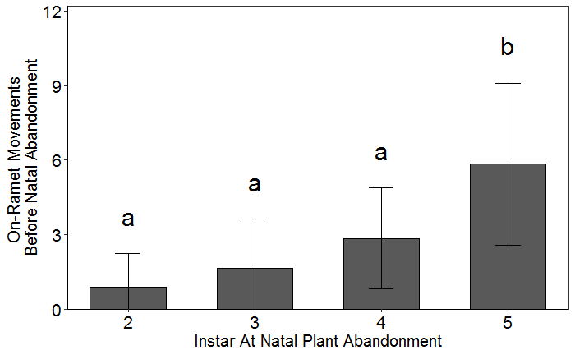

* Among Plant Movements – only 2017

> among <- glm(TimesMoved ~ YearBlock + Trial + NumPlants + Trial:NumPlants, data=PDur, family = poisson(link = "log"))

> dtm.emm <- emmeans(among, c("NumPlants", "Trial", "YearBlock"), type='response')

> joint_tests(dtm.emm)

model term df1 df2 F.ratio p.value

NumPlants 2 Inf 0.086 0.9173

Trial 3 Inf 1.740 0.1564

YearBlock 2 Inf 0.142 0.8673

NumPlants:Trial 6 Inf 0.371 0.8977

> SEamong<- summarySE(GH1718.complete, measurevar="TimesMoved", groupvars=c("NumPlants"))

> SEamong

NumPlants N TimesMoved sd se ci

1 2 29 3.689655 1.713464 0.3181824 0.6517670

2 3 21 3.666667 1.527525 0.3333333 0.6953211

3 4 27 3.481481 1.968412 0.3788210 0.7786777

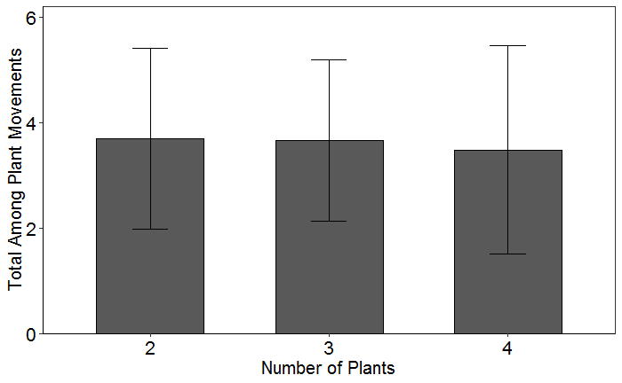

> among2=GH1718.complete$TimesMoved

> length(among2)

[1] 77

> mean(among2)

[1] 3.61039

> sd(among2)

[1] 1.740809

> max(among2)

[1] 8

> min(among2)

[1] 1

> result<-getmode(among2)

> print(result)

[1] 3

* Total Plant Abandonments – only 2017

> aban <- glm(PlantAbandonment ~ YearBlock + Trial + NumPlants + Trial:NumPlants, data=PDur, family = poisson(link = "log"))

> # Test for significance of NumPlants

> dtm.emm <- emmeans(aban, c("NumPlants", "Trial", "YearBlock"), type='response')

> joint_tests(dtm.emm)

model term df1 df2 F.ratio p.value

NumPlants 2 Inf 0.024 0.9761

Trial 3 Inf 0.984 0.3989

YearBlock 2 Inf 0.014 0.9863

NumPlants:Trial 6 Inf 0.199 0.9772

> SEaban<- summarySE(GH1718.complete, measurevar="PlantAbandonment", groupvars=c("NumPlants"))

> SEaban

NumPlants N PlantAbandonment sd se ci

1 2 29 2.896552 1.1447029 0.2125660 0.4354217

2 3 21 2.904762 0.9952267 0.2171763 0.4530218

3 4 27 2.925926 1.4391751 0.2769694 0.5693187

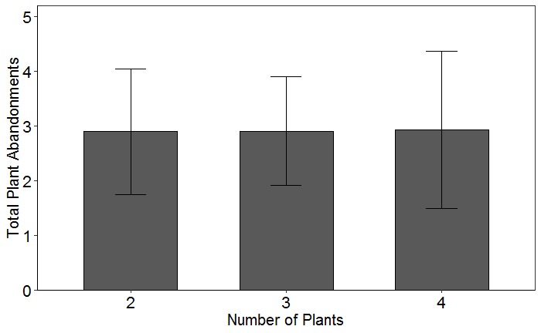

> aban2=GH1718.complete$PlantAbandonment

> length(aban2)

[1] 77

> mean(aban2)

[1] 2.909091

> sd(aban2)

[1] 1.205053

> max(aban2)

[1] 6

> min(aban2)

[1] 1

> result<-getmode(aban2)

> print(result)

[1] 2

* Abandonment by Instar – only 2017

> move<-glm(Abandonments ~ YearBlock + Trial + NumPlants + Instar + Trial:NumPlants + NumPlants:Instar, data=mvt, family = poisson(link = "log"))

> dtm.emm <- emmeans(move, c("NumPlants", "Trial", "YearBlock", "Instar"), type='response')

> joint_tests(dtm.emm)

model term df1 df2 F.ratio p.value

NumPlants 2 Inf 0.000 0.9999

Trial 3 Inf 1.065 0.3627

YearBlock 2 Inf 0.020 0.9798

Instar 4 Inf 32.435 <.0001

NumPlants:Trial 6 Inf 0.173 0.9842

NumPlants:Instar 8 Inf 0.276 0.9740

> dtm.emm2 <- emmeans(move, c("Instar"), type='response')

NOTE: Results may be misleading due to involvement in interactions

> joint_tests(dtm.emm2)

model term df1 df2 F.ratio p.value

Instar 4 Inf 32.435 <.0001

> pairs(dtm.emm2)

contrast ratio SE df z.ratio p.value

1 / 2 2.20e-05 0.019709 Inf -0.012 1.0000

1 / 3 4.00e-06 0.003615 Inf -0.014 1.0000

1 / 4 1.30e-06 0.001129 Inf -0.015 1.0000

1 / 5 4.00e-07 0.000397 Inf -0.016 1.0000

2 / 3 1.83e-01 0.116197 Inf -2.677 0.0574

2 / 4 5.73e-02 0.034019 Inf -4.815 <.0001

2 / 5 2.01e-02 0.011741 Inf -6.697 <.0001

3 / 4 3.12e-01 0.092235 Inf -3.940 0.0008

3 / 5 1.10e-01 0.029987 Inf -8.087 <.0001

4 / 5 3.51e-01 0.056774 Inf -6.473 <.0001

Results are averaged over the levels of: YearBlock, Trial, NumPlants

P value adjustment: tukey method for comparing a family of 5 estimates

Tests are performed on the log scale

> SEB<- summarySE(mvt, measurevar="Abandonments", groupvars=c("Instar"))

> SEB$Sig<- NA

> SEB$Sig<- c("a","a","a","b","c")

> SEB

Instar N Abandonments sd se ci Sig

1 1 77 0.01298701 0.1139606 0.01298701 0.02586588 a

2 2 77 0.03896104 0.1947710 0.02219622 0.04420760 a

3 3 77 0.23376623 0.4260005 0.04854726 0.09669025 a

4 4 77 0.68831169 0.6931951 0.07899692 0.15733599 b

5 5 77 1.94805195 0.8720228 0.09937622 0.19792490 c

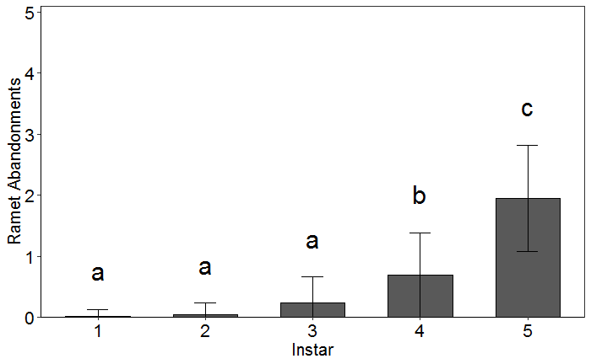

* Among Plant Movements by Instar – only 2017

> move<-glm(Movements ~ YearBlock + Trial + NumPlants + Instar + Trial:NumPlants + NumPlants:Instar, data=mvt, family = poisson(link = "log"))

> dtm.emm <- emmeans(move, c("NumPlants", "Trial", "YearBlock", "Instar"), type='response')

> joint_tests(dtm.emm)

model term df1 df2 F.ratio p.value

NumPlants 2 Inf 0.000 0.9998

Trial 3 Inf 1.922 0.1236

YearBlock 2 Inf 0.103 0.9025

Instar 4 Inf 41.255 <.0001

NumPlants:Trial 6 Inf 0.367 0.9002

NumPlants:Instar 8 Inf 0.349 0.9468

> dtm.emm2 <- emmeans(move, c("Instar"), type='response')

NOTE: Results may be misleading due to involvement in interactions

> joint_tests(dtm.emm2)

model term df1 df2 F.ratio p.value

Instar 4 Inf 41.255 <.0001

> pairs(dtm.emm2)

contrast ratio SE df z.ratio p.value

1 / 2 4.31e-05 0.023309 Inf -0.019 1.0000

1 / 3 7.20e-06 0.003885 Inf -0.022 1.0000

1 / 4 2.10e-06 0.001138 Inf -0.024 1.0000

1 / 5 7.00e-07 0.000367 Inf -0.026 1.0000

2 / 3 1.67e-01 0.104961 Inf -2.845 0.0359

2 / 4 4.88e-02 0.028863 Inf -5.106 <.0001

2 / 5 1.58e-02 0.009172 Inf -7.132 <.0001

3 / 4 2.93e-01 0.082664 Inf -4.351 0.0001

3 / 5 9.46e-02 0.024765 Inf -9.006 <.0001

4 / 5 3.23e-01 0.047592 Inf -7.670 <.0001

Results are averaged over the levels of: YearBlock, Trial, NumPlants

P value adjustment: tukey method for comparing a family of 5 estimates

Tests are performed on the log scale

> SEB<- summarySE(mvt, measurevar="Movements", groupvars=c("Instar"))

> SEB$Sig<- NA

> SEB$Sig<- c("a","a","b","c","d")

> SEB

Instar N Movements sd se ci Sig

1 1 77 0.01298701 0.1139606 0.01298701 0.02586588 a

2 2 77 0.03896104 0.1947710 0.02219622 0.04420760 a

3 3 77 0.25974026 0.4974302 0.05668743 0.11290280 b

4 4 77 0.80519481 0.8277897 0.09433539 0.18788522 c

5 5 77 2.49350649 1.2939472 0.14745897 0.29368999 d

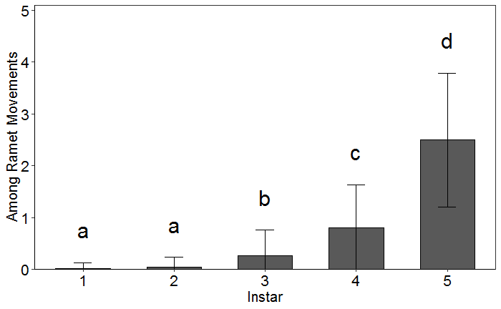

Survival 0/1 Analysis

* Survival to Pupation